

**Applied Physics for**

**Scientists and**

**Engineers**

**Lab Report 2: Conversion of Galvanometer**

**into Ammeter**

**Submitted to**

Sir. Naseer Ullah Jan

**Submitted by**

Muhammad Sadeeq

ETEA ID. 75025

Sec. C Computer

Systems Engineering Fall 2021

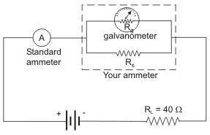

**Conversion into Ammeter:**

**Apparatus:**

1. Galvanometer
2. 2 x resistance boxes
3. DC EMF source
4. 2x key switches
5. Connecting Wires

**Diagram:**

**Procedure:**

1. Make connections for galvanometer to ammeter according to circuit.
2. Keep both the switches K1 and K2 open.
3. S.R.B. should be connected in parallel with the galvanometer.
4. Hence the circuit is complete and could be veriﬁed by measuring voltages

with actual voltmeter and also to adjust the scale.

1. H.R.B. will be connected with battery in series.
2. K1 is closed at initial so that we can apply resistance from H.R.B. for having the full scale deﬂection of galvanometer.

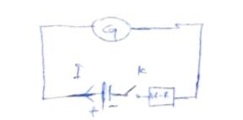

1. Now we can apply resistance from S.R.B. to show half scale deﬂection of galvanometer.
2. Note both the resistance from H.R.B. and S.R.B.
3. Repeat the process for veri ﬁcation

**Calculations:**

|  |  |  |  |  |  |
| --- | --- | --- | --- | --- | --- |
| S.No. | R | ፀ | ፀ/2 | Rs | S=Rg |
| 1 | 7200 | 20 | 10 | 1.080 | 100 |
| 2 | 7000 | 18 | 9 | 1.080 | 100 |
| 3 | 9000 | 15 | 7.5 | 1.080 | 100 |

**2nd Step:**

|  |  |  |  |  |
| --- | --- | --- | --- | --- |
| S.no | R | ፀ | ፀ/2 | Rg |
| 1 | 9000 | 15 | 7.5 | 100 |

**3rd Step:**

.

V=Vn+Vg

V=InR+IgRg

V=IgRg+IgRg

Ig=V/R+Rg

Ig=V/R+Rg

Ig=3/9000+1000

Ig=0.32mA

**Precautions:**

1. The connections should be neat and clean.
2. Wire ends should be cleaned with sandpaper
3. Shunt the galvanometer to prevent from damage .